VACCINATION



Table of Contents

Introduction 3

1. Web interface 3

Registration 4

Services 4

FAQ 6

Contact 7

Login 8

8

2. Mobile Interfaces 8

# Introduction

Vaccination project will have two interfaces: 1. Web interface 2. Mobile interface

# Web interface

Web interface have initially five parts:

1. Registration 2. Services 3.FAQ 4.Contact 5. Sign in

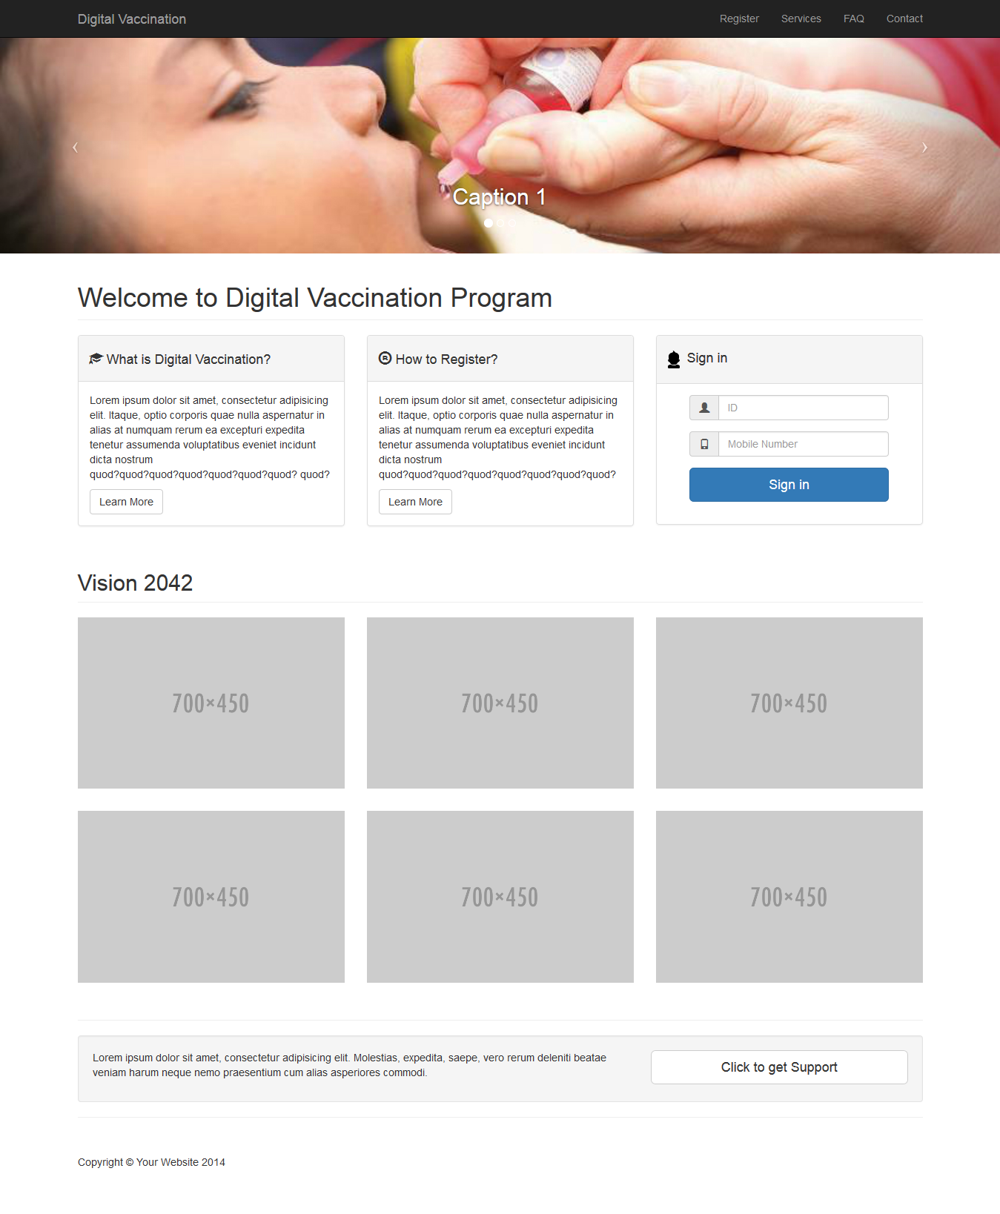

# Registration

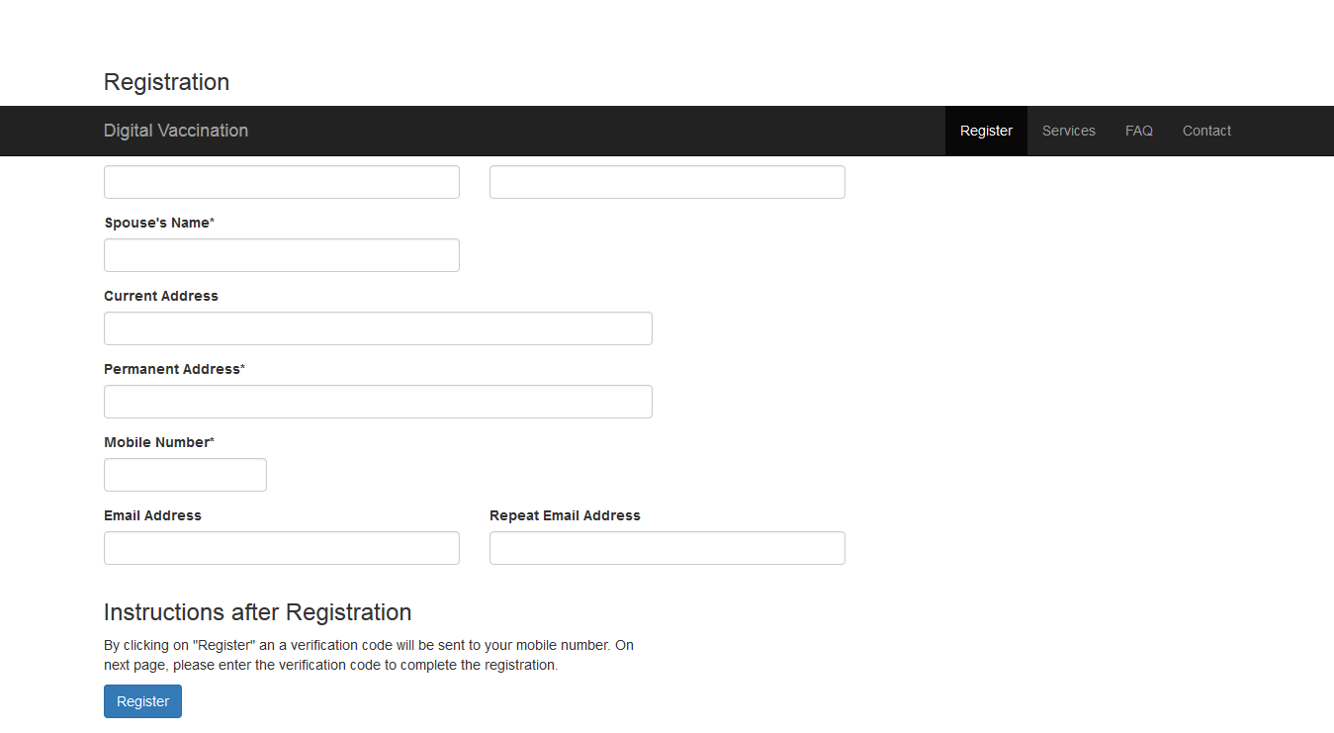

In the registration field there is different fields- **Baby’s Name:** Newborn’s full name**, Father’s Name:** Father’s full name**, Mother’s Name:** Mother’s full name**, Current Address:** parent’s current address- Through this we will trace the nearest vaccination center like-hospital ,clinic ,health care center **, Permanent address:** parent’s permanent address, **Mobile Number:** father/ mother mobile number, **Birth Certificate ID:** child’s birth certificate ID, **Email address & repeat Email address:** for email confirmation ,notification , communication, **Instruction after registration:** On **Register** button-By clicking on "Register" button a verification code will be sent to your mobile number. On next page, please enter the verification code to complete the registration.

# Services

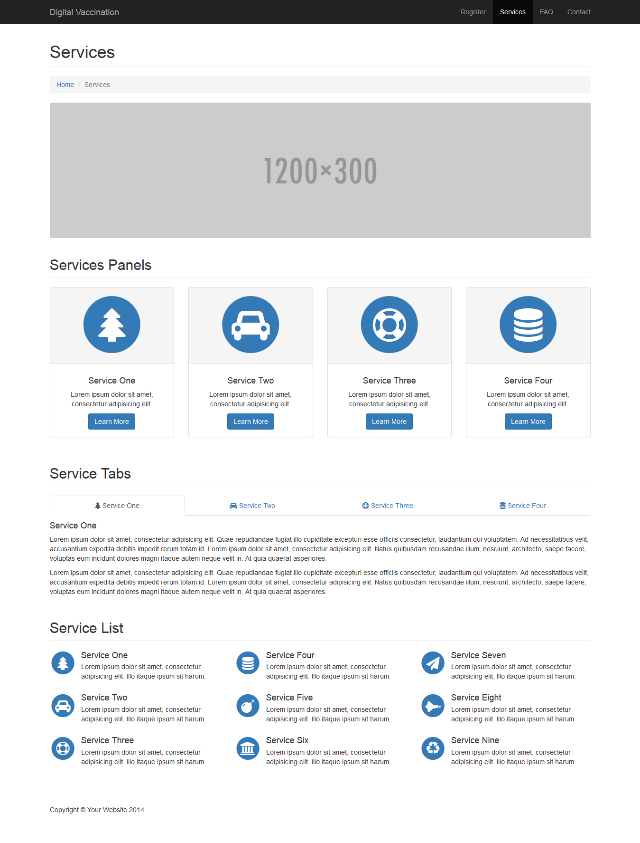

# FAQ

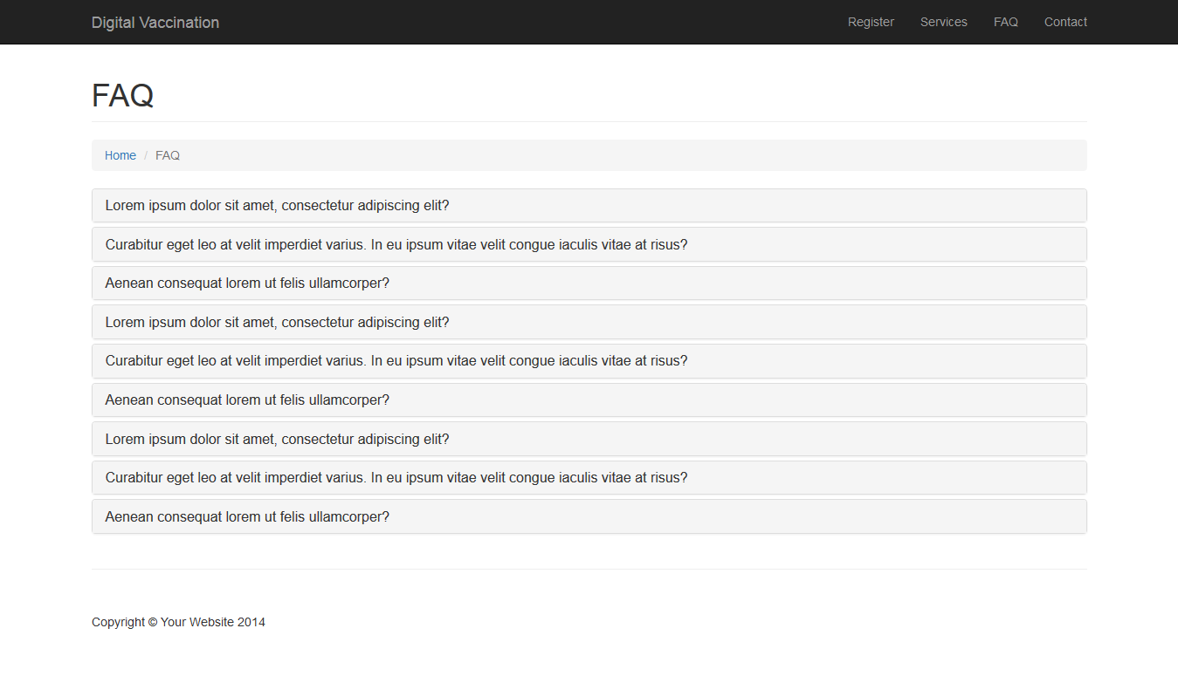

# Contact

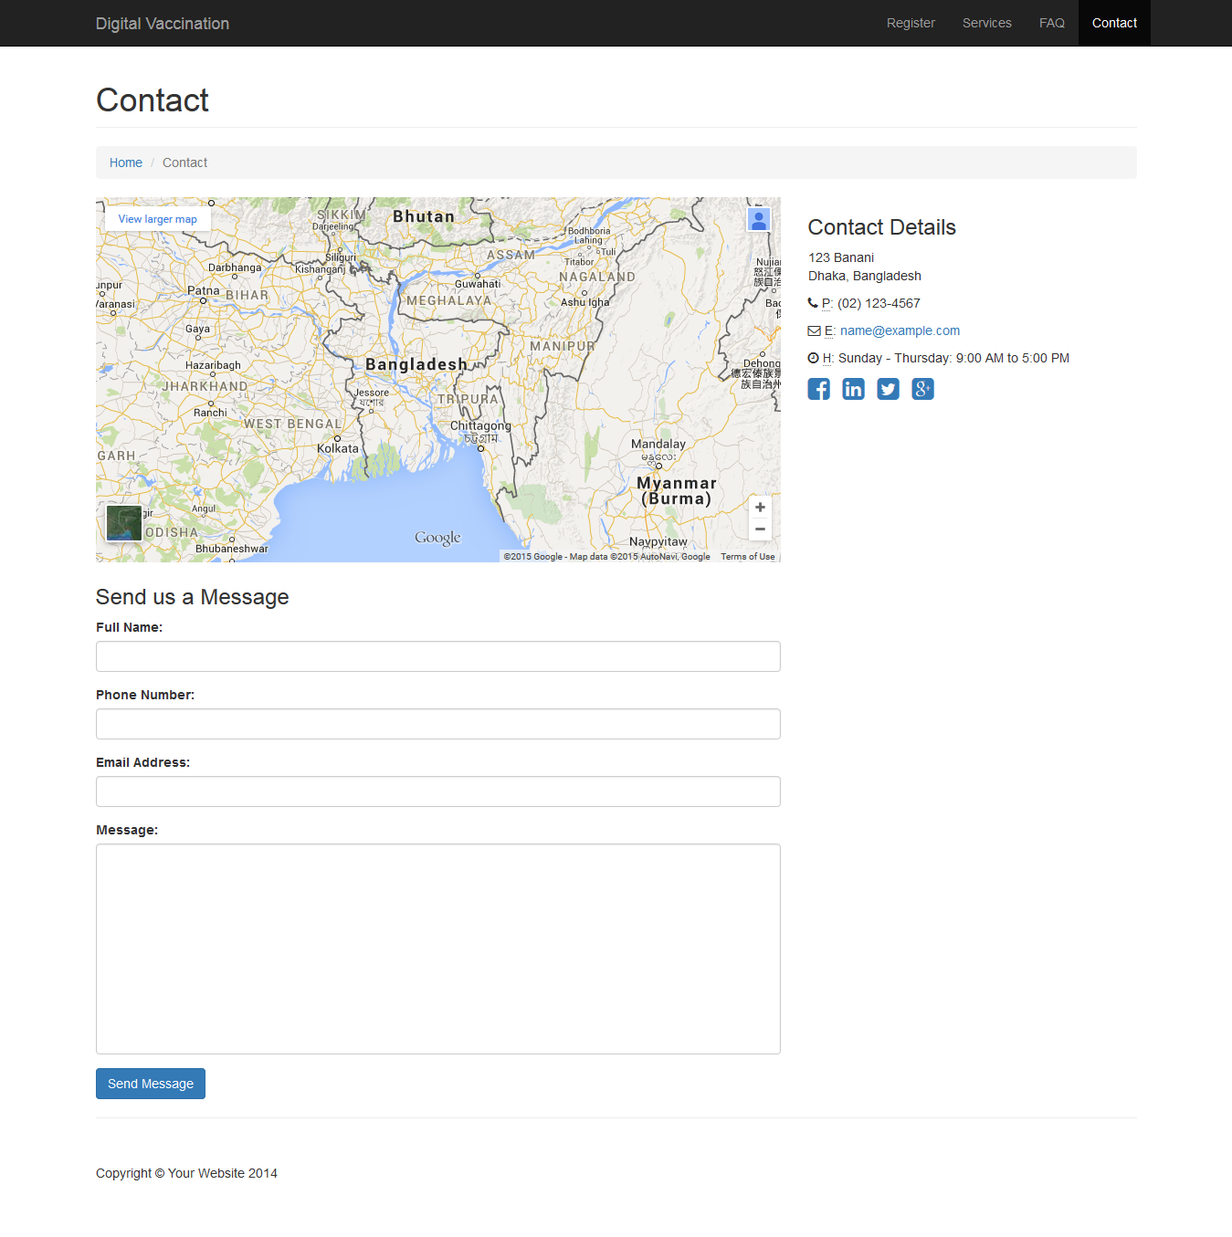

# Login

# 

Initially we have Login information in the Home page. There is two field’s information required to login- **ID & Mobile Number**. **ID** can be child’s birth registration number/ birth date. **Mobile Number** can be father’s/mother’s mobile number. Already registered parents can login by giving ID/Mobile Number. New member can create account by “Sign up Here”. **Comment:** Root users can forget the information they provided. So a **“forget information”** need to be introduced.

# 2. Mobile Interfaces

There is two interfaces should be introduced- 1.Two Way SMS Services 2. Mobile application

TWO Way SMS Services

Two way SMS services are for getting the feedback from root level. Users will send a SMS to a particular mobile number or any short code. They will get an answer/notification from that.

Mobile Application

Dedicated mobile applications will be introduced for the smart phone users.

History:

|  |  |  |  |
| --- | --- | --- | --- |
|  |  |  |  |
|  |  |  |  |